Electrical Energy
Yr 9 2002 version

Name ___________________________________ GT.P.9.002

Resistance

A resistor conducts electricity but resists the flow of current.
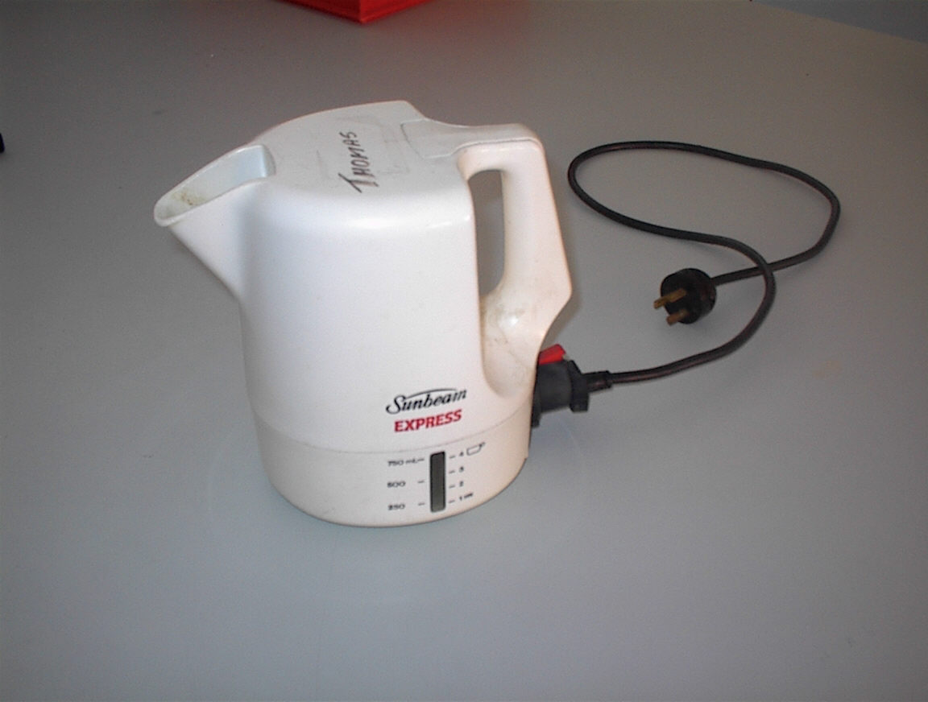

When electrons in the circuit encounter resistance energy is given up to the resistance.
Examples of resistances are: heating coils in kettles and hot plates, motors, lamps.
Resistances can be long, thin wires or electronic devices.

The greater the resistance the greater the quantity of energy it receives as the electric current passes through it.

Resistance is measured in ohms (Ω).
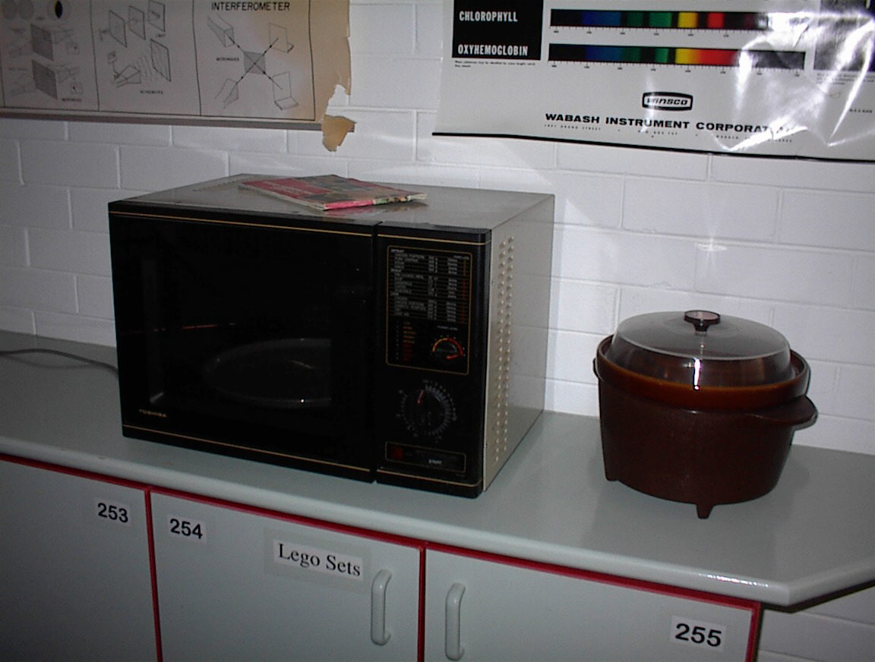
Νichrome metal has a high resistance to electricity.

It is used to convert electrical energy into heat energy.

The resistance of a substance depends upon three factors:
1 The nature of the substance
2 Its diameter
3 Its length

Questions

1 What happens to the resistance as the thickness of the resistor changes? (increases, decreases, remains the same)

2 What happens to the resistance of the resistor as the length changes? (increases, decreases, remains the same)

3 Does the type of substance a conductor is made of effect the resistance of a conductor? (yes or no)

- Explain your answer to Q3

- If you wanted to make a resistor which had very high resistance it would have certain properties. Choose words from the following list to describe your resistor. (Thin, thick, long short, nichrome, copper.)

- Use reference books to find out what the high resistance filament in an electric lamp is made of.

Answer ________________________

- Describe what energy transformations are taking place in the filament of an electric lamp when it is switched “on”.

- What is the main type of waste energy produced by an electric lamp when it is switched “on”?

- A toaster is another device which uses a resistor. Would you expect the resistor in a toaster to be of high or low resistance?

10 Explain your answer to Q9 above.

